**SQL Training**

### Attention

1. The <XXXX> used in this article represents the employee ID. Please replace it with your own employee ID.

Alrady change it TOO

### Create data object

#### Create tables and table indexes

Table ：CUX_OM_CUSTOMERS_XXXX

For storing customer information。

| Field | Type | Nullable | Default Value | Description |
| --- | --- | --- | --- | --- |
|  |  |  |  |  |
| CUSTOMER_ID | BIGINT | N |  |  |
| CUSTOMER_NUMBER | VARCHAR(30) | N |  |  |
| CUSTOMER_NAME | VARCHAR(100) | N |  |  |
| TELEPHONE | VARCAHR(50) | Y |  |  |
| START_DATE_ACTIVE | DATE | Y |  |  |
| END_DATE_ACTIVE | DATE | Y |  |  |
| CREATED_BY | BIGINT | N |  |  |
| CREATION_DATE | DATE | N |  |  |
| LAST_UPDATED_BY | BIGINT | N |  |  |
| LAST_UPDATE_DATE | DATE | N |  |  |
| LAST_UPDATE_LOGIN | BIGINT | Y |  |  |

Create indexes：

| Index | Unique | Field | Description |
| --- | --- | --- | --- |
|  |  |  |  |
| CUX_OM_CUSTOMERS_XXXX_U1 | Y | CUSTOMER_ID |  |
| CUX_OM_CUSTOMERS_XXXX_U2 | Y | CUSTOMER_NUMBER |  |
| CUX_OM_CUSTOMERS_XXXX_U3 | Y | CUSTOMER_NAME |  |

Table：CUX_OM_ITEMS_XXXX

For storing product information。

| Field | Type | Nullable | Default Value | Description |
| --- | --- | --- | --- | --- |
|  |  |  |  |  |
| ITEM_ID | BIGINT | N |  |  |
| ITEM_NUMBER | VARCHAR(30) | N |  |  |
| ITEM_NAME | VARCHAR(100) | N |  |  |
| UOM_CODE | VARCHAR(25) | Y |  |  |
| START_DATE_ACTIVE | DATE | Y |  |  |
| END_DATE_ACTIVE | DATE | Y |  |  |
| CREATED_BY | BIGINT | N |  |  |
| CREATION_DATE | DATE | N |  |  |
| LAST_UPDATED_BY | BIGINT | N |  |  |
| LAST_UPDATE_DATE | DATE | N |  |  |
| LAST_UPDATE_LOGIN | BIGINT | Y |  |  |

Create indexes：

| Index | Unique | Field | Description |
| --- | --- | --- | --- |
|  |  |  |  |
| CUX_OM_ITEMS_XXXX_U1 | Y | ITEM_ID |  |
| CUX_OM_ITEMS_XXXX_U2 | Y | ITEM_NUMBER |  |

table：CUX_OM_HEADERS_XXXX

For storing sales order header information。

| Field | Type | Nullable | DefaultValue | Description |
| --- | --- | --- | --- | --- |
|  |  |  |  |  |
| HEADER_ID | BIGINT | N |  |  |
| ORG_ID | BIGINT | Y | 101 |  |
| ORDER_NUMBER | VARCHAR(30) | N |  |  |
| CUSTOMER_ID | BIGINT | Y |  |  |
| ORDER_DATE | DATE | N |  |  |
| ORDER_STATUS | VARCHAR(30) | Y |  | status list:  UNAPPROVED  APPROVED  CANCELLED  CLOSED |
| DESCRIPTION | VARCHAR(240) | Y |  |  |
| CREATED_BY | BIGINT | N |  |  |
| CREATION_DATE | DATE | N |  |  |
| LAST_UPDATED_BY | BIGINT | N |  |  |
| LAST_UPDATE_DATE | DATE | N |  |  |
| LAST_UPDATE_LOGIN | BIGINT | Y |  |  |
| ATTRIBUTE_CATEGORY | VARCHAR(30) | Y |  |  |
| ATTRIBUTE1 | VARCHAR(150) | Y |  |  |
| ATTRIBUTE2 | VARCHAR(150) | Y |  |  |
| ATTRIBUTE3 | VARCHAR(150) | Y |  |  |
| ATTRIBUTE4 | VARCHAR(150) | Y |  |  |
| ATTRIBUTE5 | VARCHAR(150) | Y |  |  |
| ATTRIBUTE6 | VARCHAR(150) | Y |  |  |
| ATTRIBUTE7 | VARCHAR(150) | Y |  |  |
| ATTRIBUTE8 | VARCHAR(150) | Y |  |  |
| ATTRIBUTE9 | VARCHAR(150) | Y |  |  |
| ATTRIBUTE10 | VARCHAR(150) | Y |  |  |
| ATTRIBUTE11 | VARCHAR(150) | Y |  |  |
| ATTRIBUTE12 | VARCHAR(150) | Y |  |  |
| ATTRIBUTE13 | VARCHAR(150) | Y |  |  |
| ATTRIBUTE14 | VARCHAR(150) | Y |  |  |
| ATTRIBUTE15 | VARCHAR(150) | Y |  |  |

Create Indexes：

| Index | Unique | Field | Description |
| --- | --- | --- | --- |
|  |  |  |  |
| CUX_OM_HEADERS_XXXX _U1 | Y | HEADER_ID |  |
| CUX_OM_HEADERS_XXXX _U2 | Y | ORDER_NUMBER |  |
| CUX_OM_HEADERS_XXXX _N1 |  | CUSTOMER_ID |  |

Table：CUX_OM_LINES_XXXX

For storing sales order line information。

| Field | Type | Nullable | Default Value | Description |
| --- | --- | --- | --- | --- |
|  |  |  |  |  |
| LINE_ID | BIGINT | N |  |  |
| HEADER_ID | BIGINT | N |  |  |
| LINE_NUMBER | VARCHAR(30) | N |  |  |
| ITEM_ID | BIGINT | N |  |  |
| UNIT_PRICE | DECIMAL(10,2) | Y |  |  |
| QUANTITY | DECIMAL(10,2) | Y |  |  |
| DESCRIPTION | VARCHAR(240) | Y |  |  |
| ADDITION1 | VARCHAR(150) | Y |  |  |
| ADDITION2 | VARCHAR(150) | Y |  |  |
| ADDITION3 | VARCHAR(150) | Y |  |  |
| ADDITION4 | VARCHAR(150) | Y |  |  |
| ADDITION5 | VARCHAR(150) | Y |  |  |
| CREATED_BY | BIGINT | N |  |  |
| CREATION_DATE | DATE | N |  |  |
| LAST_UPDATED_BY | BIGINT | N |  |  |
| LAST_UPDATE_DATE | DATE | N |  |  |
| LAST_UPDATE_LOGIN | BIGINT | Y |  |  |
| ATTRIBUTE_CATEGORY | VARCHAR(30) | Y |  |  |
| ATTRIBUTE1 | VARCHAR(150) | Y |  |  |
| ATTRIBUTE2 | VARCHAR(150) | Y |  |  |
| ATTRIBUTE3 | VARCHAR(150) | Y |  |  |
| ATTRIBUTE4 | VARCHAR(150) | Y |  |  |
| ATTRIBUTE5 | VARCHAR(150) | Y |  |  |
| ATTRIBUTE6 | VARCHAR(150) | Y |  |  |
| ATTRIBUTE7 | VARCHAR(150) | Y |  |  |
| ATTRIBUTE8 | VARCHAR(150) | Y |  |  |
| ATTRIBUTE9 | VARCHAR(150) | Y |  |  |
| ATTRIBUTE10 | VARCHAR(150) | Y |  |  |
| ATTRIBUTE11 | VARCHAR(150) | Y |  |  |
| ATTRIBUTE12 | VARCHAR(150) | Y |  |  |
| ATTRIBUTE13 | VARCHAR(150) | Y |  |  |
| ATTRIBUTE14 | VARCHAR(150) | Y |  |  |
| ATTRIBUTE15 | VARCHAR(150) | Y |  |  |

Create Indexes：

| Index | Unique | Field | Description |
| --- | --- | --- | --- |
|  |  |  |  |
| CUX_OM_LINES_XXXX _U1 | Y | LINE_ID |  |
| CUX_OM_LINES_XXXX _N1 |  | HEADER_ID |  |
| CUX_OM_LINES_XXXX _N2 |  | ITEM_ID |  |

#### Import data

excel：《1 – Table Data.xls》

1．CUX_OM_CUSTOMERS_XXXX

2．CUX_OM_ITEMS_XXXX

4．CUX_OM_HEADERS_XXXX

5．CUX_OM_LINES_XXXX

### Questions

#### NO.01

Please create the above objects in the database: table, table index。

#### NO.02

Please import the corresponding table data in the file: "1 – Table Data.xlsx" into the table。

I already import the Table Data.xlsx

#### NO.03

Create a view：CUX_OM_HEADERS_V

select * from CUX_OM_HEADERS_V

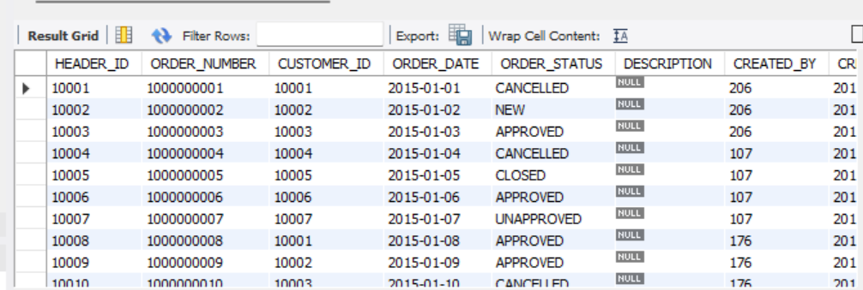

#### NO.04

Write SQL to display the following information and sort it by customer_number and order_number in ascending order。

SELECT order_number, customer_number, customer_name, order_date, order_status, description

FROM cux_om_headers_46326 inner join cux_om_customers_46326 ON

cux_om_headers_46326.CUSTOMER_ID = cux_om_customers_46326.CUSTOMER_ID

#### 

#### NO.05

Write SQL to display order and order line information, sorted by order number and line number in ascending order (including orders with all statuses)

SELECT CUX_OM_HEADERS_46326.ORDER_NUMBER, CUX_OM_CUSTOMERS_46326.CUSTOMER_NAME,

CUX_OM_HEADERS_46326.ORDER_DATE, CUX_OM_HEADERS_46326.ORDER_STATUS, CUX_OM_LINES_46326.LINE_NUMBER, CUX_OM_ITEMS_46326.ITEM_NUMBER,

CUX_OM_ITEMS_46326.ITEM_NAME FROM CUX_OM_CUSTOMERS_46326 CROSS JOIN CUX_OM_HEADERS_46326, CUX_OM_LINES_46326,

CUX_OM_ITEMS_46326 ORDER BY CUX_OM_HEADERS_46326.ORDER_NUMBER ASC, CUX_OM_LINES_46326.LINE_NUMBER ASC;

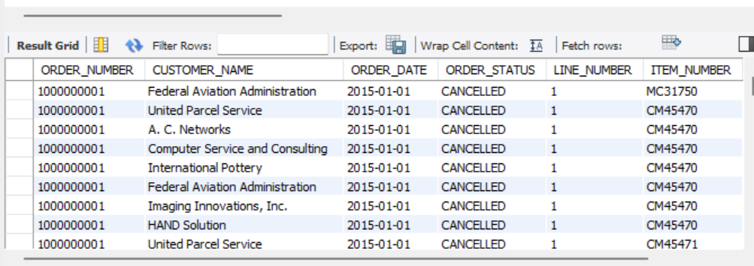

#### NO.06

Write SQL to display products purchased by customers

SELECT CUX_OM_CUSTOMERS_46326.CUSTOMER_NAME, CUX_OM_CUSTOMERS_46326.CUSTOMER_NUMBER,

CUX_OM_ITEMS_46326.ITEM_NUMBER, CUX_OM_ITEMS_46326.ITEM_NAME, CUX_OM_ITEMS_46326.UOM_CODE

FROM CUX_OM_CUSTOMERS_46326 CROSS JOIN CUX_OM_ITEMS_46326 WHERE CUX_OM_CUSTOMERS_46326.CUSTOMER_NUMBER = '1101'AND CUX_OM_ITEMS_46326.ITEM_NUMBER = 'SB86662';

#### 

#### NO.07

Write SQL to count all orders (excluding canceled orders) and calculate the average sales unit price and the highest and lowest unit price by product.

SELECT

cux_om_items_46326.ITEM_NUMBER,

cux_om_items_46326.ITEM_NAME,

AVG(cux_om_lines_46326.UNIT_PRICE) AS Avg_Unit_Price,

MAX(cux_om_lines_46326.UNIT_PRICE) AS Max_Unit_Price,

MIN(cux_om_lines_46326.UNIT_PRICE) AS Min_Unit_Price

FROM

cux_om_items_46326

JOIN

cux_om_lines_46326 ON cux_om_items_46326.ITEM_ID = cux_om_lines_46326.ITEM_ID

JOIN

cux_om_headers_46326 ON cux_om_lines_46326.HEADER_ID = cux_om_headers_46326.HEADER_ID

JOIN

cux_om_customers_46326 ON cux_om_headers_46326.CUSTOMER_ID = cux_om_customers_46326.CUSTOMER_ID

WHERE

cux_om_customers_46326.CUSTOMER_NUMBER = '1101'

AND cux_om_items_46326.ITEM_NUMBER = 'SB86662'

#### 

#### NO.08

Write SQL to query customer information about canceled orders.

SELECT cux_om_customers_46326.CUSTOMER_NUMBER, cux_om_customers_46326.CUSTOMER_NAME, cux_om_customers_46326.TELEPHONE,

cux_om_items_46326.START_DATE_ACTIVE, cux_om_items_46326.END_DATE_ACTIVE from cux_om_customers_46326

JOIN cux_om_headers_46326 ON cux_om_customers_46326.CUSTOMER_ID = cux_om_headers_46326.HEADER_ID

JOIN cux_om_items_46326 on cux_om_items_46326.ITEM_ID = cux_om_headers_46326.HEADER_ID WHERE ORDER_STATUS = "CANCELLED"

#### 

#### NO.09

Write SQL to count the company's total sales in 2015. (All orders with status CANCELLED are excluded from statistics)

SELECT SUM(UNIT_PRICE * QUANTITY) AS cux_om_lines_46326

FROM cux_om_headers_46326

JOIN cux_om_lines_46326 ON cux_om_headers_46326.HEADER_ID = cux_om_lines_46326.HEADER_ID

WHERE YEAR(cux_om_headers_46326.ORDER_DATE) = 2015

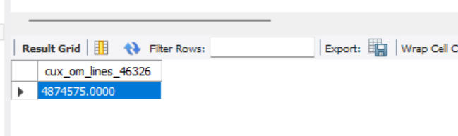

#### NO.10

Write a script to add an index to the table: CUX_OM_ITEMS_XXXX: a normal index, and the applicable field: ITEM_NAME.

